**INSTRUCTION GUIDE**

INTRODUCTION-Before getting started, let’s take a brief tutorial on the robot control and functions, as well as what is needed to prepare the robotic vehicle for operation.

Contents and Parts Identification:

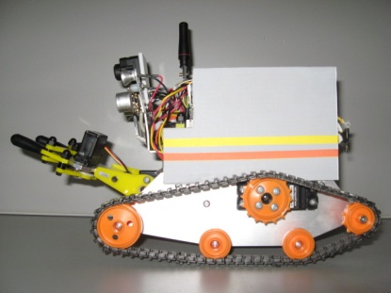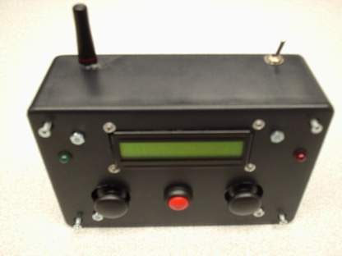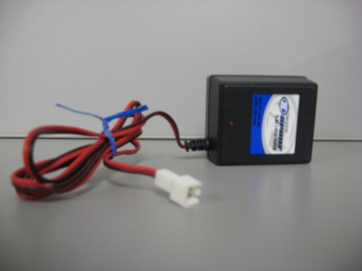

[ROBOT] [CONTROLLER] [WALL TRANSFORMER CHARGER]

Control of the robot is done through the wireless controller (refer to figure 1 below to familiarize yourself with the controls).

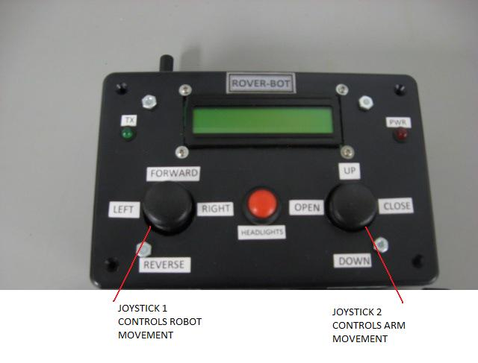

[FIGURE 1]

Joystick 1(left side) controls the movement of the robot. It has the capability of moving forward, reverse, left and right. Joystick 2(right side) controls the movement of the robotic arm. It has the capability of grasping and lifting objects. Arm movement includes up, down, open and close. The LCD display interface on the wireless controller brings data over from the robot and will output it on the screen. The LCD has two lines available for visual data. The following data will show up on the LCD screen:

-***Direction*** of the vehicle based on the joystick 1 position. The actual data displayed will be “Neutral, Forward, Reverse, Left and Right”. This will be displayed on line 1, and is dependent upon joystick 1 position.

-***Ping sensor distance*** (measures distance from objects). The actual data displayed will be

“Ping: xxx”, where x=distance in inches. This will be displayed on line 2.

-***Infrared sensor warning*** (only displays when the robot is too close to an object when reverse is engaged, and will shut off the servo motors). The actual data displayed will be “IR Detected!”. This will be displayed on line 2.

-***Positioning of the robotic arm***. The actual data displayed will be “Arm Up” or “Arm Down” and is dependent upon joystick 2 position. This will be displayed on line 1 in conjunction with the direction data.

-***Positioning of the claw.*** The actual data displayed will be “A Open” or “A Close” and is dependent upon joystick 2 position. This will be displayed on line 1 in conjunction with the direction.

The red pushbutton (located between the two joysticks) will operate the headlights that are located on the front of the robot. Pushing the button once, turns the lights on and pushing the button a second time will turn the lights off. The two LED’s that are located on the rear of the robot act as turn signals, and will light up independently when the joystick 1 left or right direction is engaged.

Additionally, there are two LED status indicators on the wireless controller, and two for the robot.

Controller: The first LED is green and is labeled “Tx”. This will flash to show that wireless communication is being achieved. The second Led is red and is labeled “Pwr”. When the power is switched on, it will stay on continuously.

Robot: The robot vehicle also has LED Tx and Pwr indicators, which are both green. The “Tx” is located on the top of the plastic housing, and will flash when the wireless is active. The “Pwr” is located on the microprocessor that is attached to the tracked vehicle frame (under the plastic housing) and will stay on continuously when the vehicle is powered on.

The camera will need additional hardware to operate. See **Section 2** for additional instructions.

The robotic arm is limited to picking up items that are less than 8 ounces. Trying to pick up more weight than this is not recommended as damage to the robot may occur.

**To prepare your robot for operation, see SECTION 1: Battery installation/removal and *charging* and SECTION 2: Preparing the Robot and Controller for use. Additional troubleshooting tips are included in Sections 3, 4, and 5.**

**SECTION 1: Battery installation/removal and charging**

* **STEP 1.1** Controller Battery (2- 9V Battery)

**a.** Remove 4 outer screws.

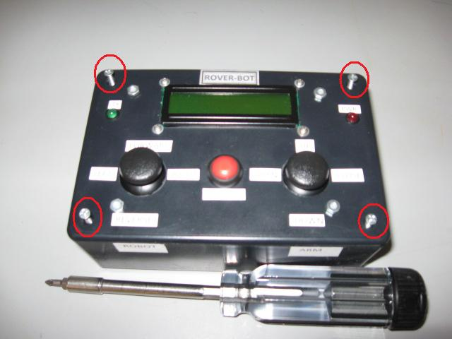

**b.** Carefully remove top cover.

**c.** Locate battery plug-ins, install batteries.

**d.** Replace top cover and tighten screws.

* **STEP 1.2**  Robot Battery (1-rechargeable 7.2V)

**a.** Locate the charging receptacle located in the rear of the Robot. It is labeled Power Source/Charging

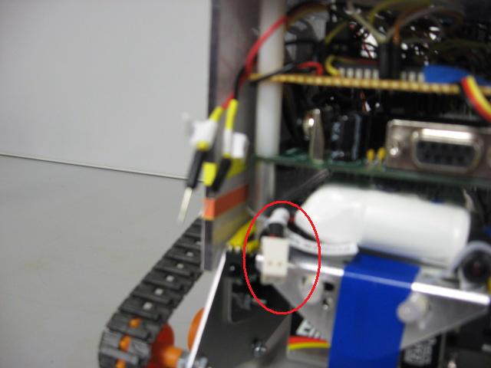

**b.** Using the included wall transformer, plug it into an AC outlet and charge the rechargeable battery by plugging it into the robot.

*Note- This usually takes about 2 hours to fully charge.

**c.** Unplug the wall transformer from the robot and wall receptacle and put it away.

**d.** Locate the two wires near the charging receptacle of the robot and plug these two wires into the charging receptacle of the robot.

*Note-The two wires and the charging receptacle are labeled “1” and “2”. Plug these in with the corresponding number (“1” into “1”, and “2” into “2”).

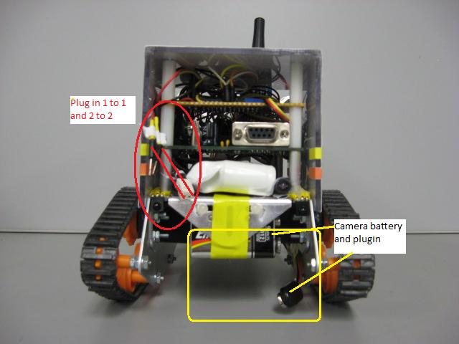

* **STEP 1.3** Camera Battery (1-9V Battery)-Optional

a. Locate and install a battery for the camera. (See above photo) See Section 2 for additional instructions.

*Note-This battery is optional and is for the camera only. The robot and controller can be operated without this battery.

**SECTION 2: Preparing the Robot and Controller for use**

*Note: The Controller switch must be turned on first to activate the wireless correctly.

* **STEP 2.1** Locate On/Off switch on Controller Box and turn to the on position.

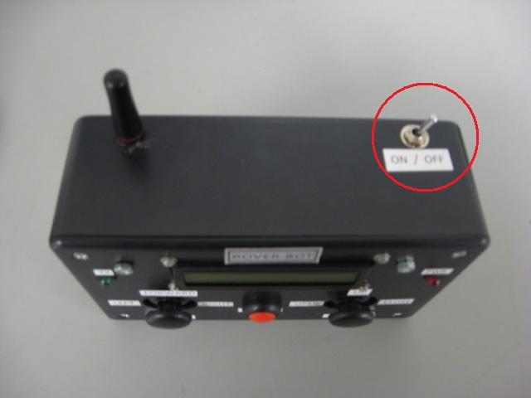

* **STEP 2.2** Locate On/Off switch on Robot and turn to the on position.

*Note-switch must be in position 2 for the robot to function.

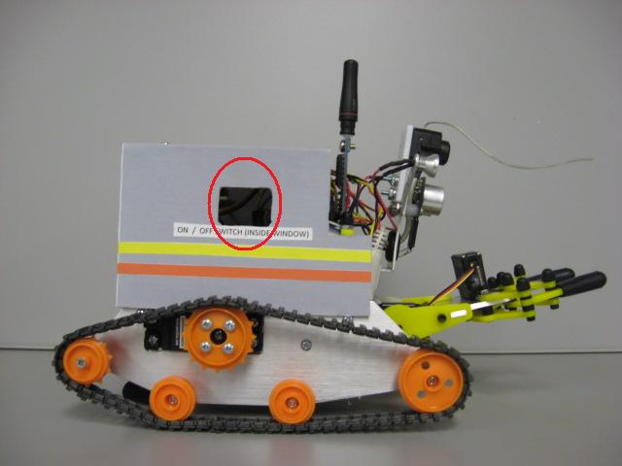

* **STEP 2.3** Ensure that the wireless LED indicators (TX) on both the controller and robot are flashing.

*Note-see troubleshooting sections 3 and 4 if LEDs are not flashing.

* **STEP 2.4 Step 2.4 is optional and can be skipped if the camera on the robot will not be implemented.** For camera operation, locate the power cords, 7 inch LCD, tuner, and cables. Make the connections for the cables, numbers 3 through 9. Match numbers to identical numbers. (i.e. Plug in 3 to 3). When these connections are complete, plug in the LCD power cord and the tuner power cord. Ensure that a 9V battery for the camera is plugged in on the robot (see step 1.3). Raise the “Tuners” antenna into a vertical position (does not pull out, just turn up). Turn on the LCD and adjust “Tune” knob until the camera is working. Proceed to step 2.5
* **STEP 2.5** Robot is ready to operate.

*Note-to familiarize yourself with the controls; please refer to figure 1 in the introduction section.

**SECTION 3:Troubleshooting Controller**

A. Red Pwr LED light on controller box not on:

-No power is present to the controller. Check the battery for loose connections and/or replace the battery if necessary.

B. Green Tx LED light on wireless controller box not flashing:

-Wireless transmission has been lost or dropped, and/or robot has lost power. Ensure robot and wireless batteries are good. If batteries are ok, locate the reset switch on the robotic vehicle *through the window* (next to on/off switch) and push to reset the robot. Refer to the following Figure 2 for example reset switch.

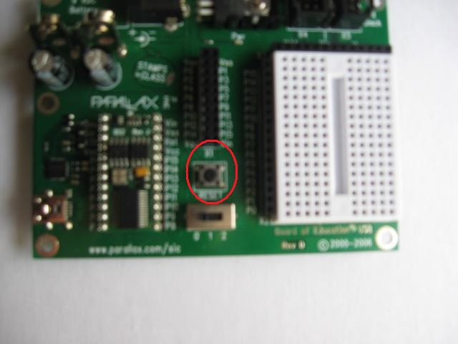

[Figure 2] Example reset switch location on microprocessor board

**SECTION 4: Troubleshooting Robot**

A. Green PWR LED light on robot not on (located under the plastic housing on the microprocessor):

-No power is present to the robot. Check battery and charge if necessary.

B. Green TX LED light on robot not flashing (located on the top of the plastic housing near the rear of the robot):

-Wireless transmission has been lost or dropped, and/or robot has lost power. Ensure robot and wireless battery are good. If batteries are ok, locate reset switch on the robotic vehicle through the window and reset the robot.

**SECTION 5: Troubleshooting Camera**

A. No picture on 7 inch LCD:

-Ensure camera batter is fully charged.

-Verify all connections on cables, LCD, and tuner.

-When adjusting “tuner” knob, increment slowly to dial in.

-Check to ensure antennae has been raised into a vertical position.

**ENDNOTES:**

To reprint this manual or for other robot documentation, please see the CD located in the robot storage box.

